**Operating System Exploration Results**

Christopher M. Finster

CST – 221 Operating Systems Concepts

26 January 2018

Operating System Exploration Results

Linux operating systems has many useful tools to assist users in performing various tasks. Table 1 below shows 5 of these features and how to access each one. Explanation of how I think each work to follow:

Table 1

|  |  |
| --- | --- |
| FEATURE | HOW TO ACCESS |
| List Directory | ls |
| APT Package Handling | apt-get [ACTION] PACKAGE |
| Text Replacement | sed -i s/String to find/String to replace with/g [FILE] |
| Print Contents of a File | cat [FILE] |
| Add User | sudo adduser $loginname |

List Directory

This feature is useful for navigating the directories in your system. It allows you to see what files are present in the current directory which can help you locate files when you do not know the exact location. I think it is most useful in conjunction with the change directory command (cd).

What I believe is happening behind the scenes when you enter the ls command is the system is searching for directory and file names or headers in the current active directory. When it finds a directory or file, it is making a copy of its name or header and pasting it into a list or stack. When it reaches the end of the directory it returns the list and prints it to the terminal.

Screenshot provided for reference. See figure 1 below.

APT Package Handling

This feature allows you to do many different things. The function I have used it to install software as I have figured out how to get everything working properly. Specifically, I have used the command sudo apt-get install [application name]. I have found it helpful when software was missing that I needed to complete work.

What I think is happening when this command is executed is the system is verify permission indicated by sudo and attempting to retrieve installation software for the program specified. I imagine this is web-based searching a database of software. If the software is found, it downloads and runs the installation software. In my test of this feature, the system told me I already had the most up to date version of the software.

Screenshot provided for reference. See figure 2 below.

Text Replacement

I believe the text replacement feature may be one of the coolest and most useful features to me in the future, specifically with writing code. I have often found myself changing the names of classes, methods, variables, etc. within a program or finding that I had misspelled a word and lazily copied and pasted it several times within several hundred lines of code. With the text replace feature, fixing this issue would be easy.

What I think the command is doing is calling stream editor to substitute the original text or string with new text or a new string for every occurrence and save the original file with the changes.

Screenshot provided for reference. See figure 3 below.

Print Contents of a File

This feature is necessary, especially in the absence of a Graphical User Interface (GUI). Utilizing this command allows you to see what is in a file. What good is having files if you cannot read them?

What I think is going on when this command is executed is the system is reading the contents of the file, copying them, and pasting it as text in the terminal.

Screenshot provided for reference. See figure 3 below.

Add User

This feature is useful if multiple people will be using the computer and you want to keep your work separate.

What I think is happening when the command is executed is the system is allocating space and creating an independent directory for the user provided. I think it is cool the system prompts for a new password to keep the separate information secured automatically.

Screenshot provided for reference. See figure 4 below.

Figure 1

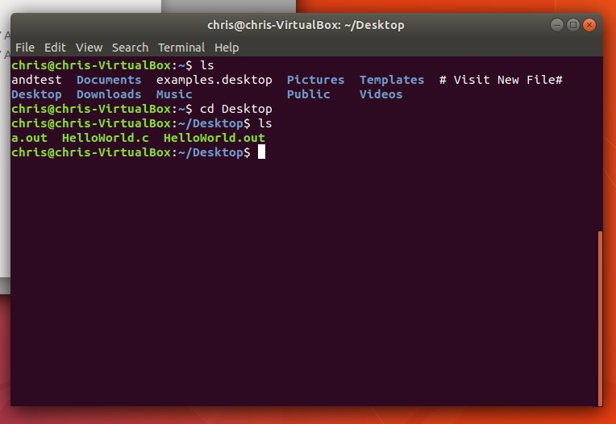

Figure 2

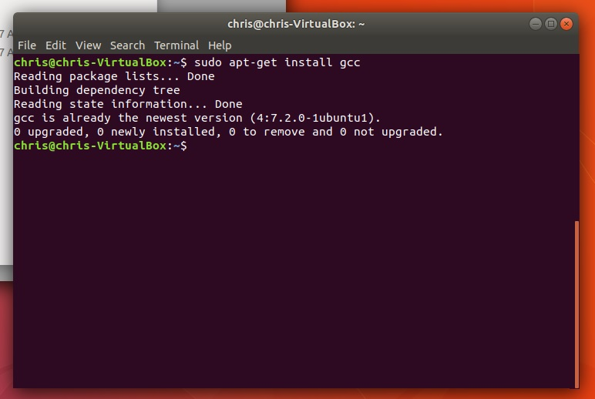

Figure 3

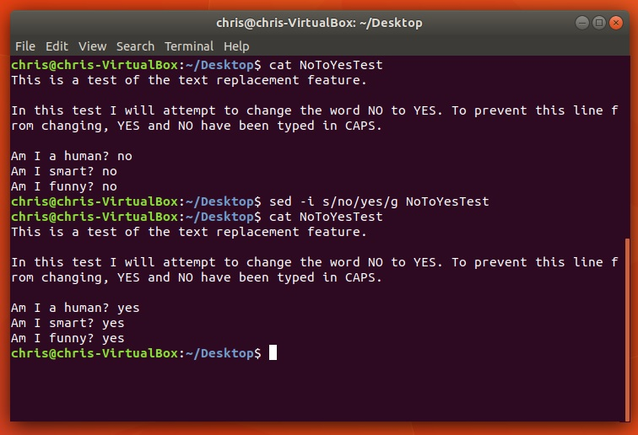

Figure 4

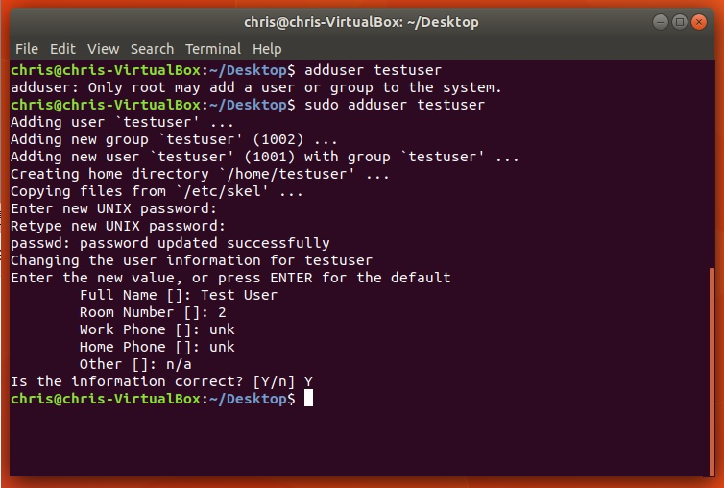

Proof of Linux availability and use:

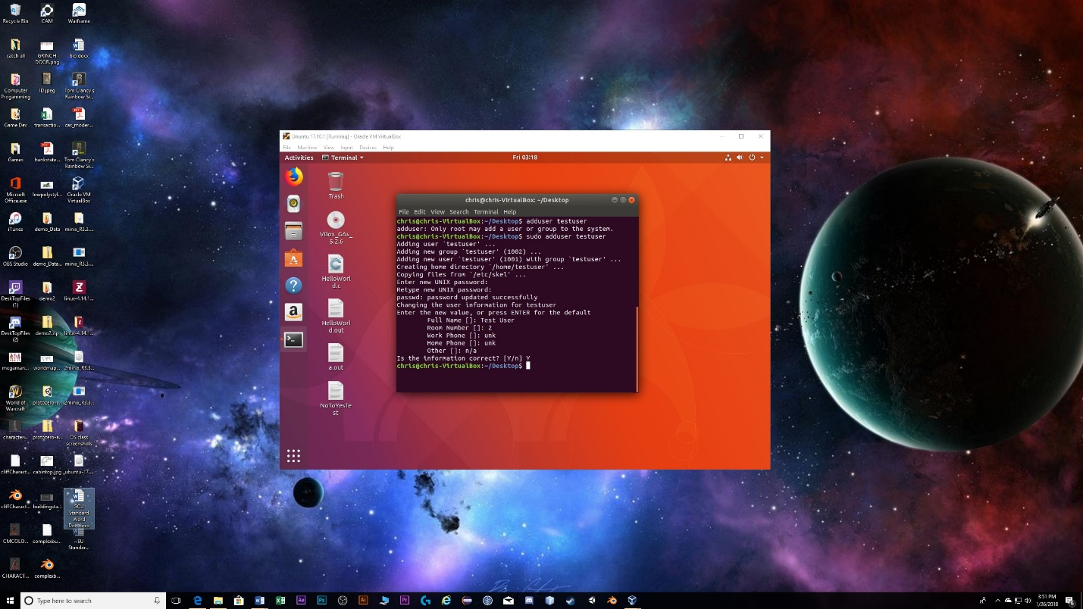

Hello World program execution:

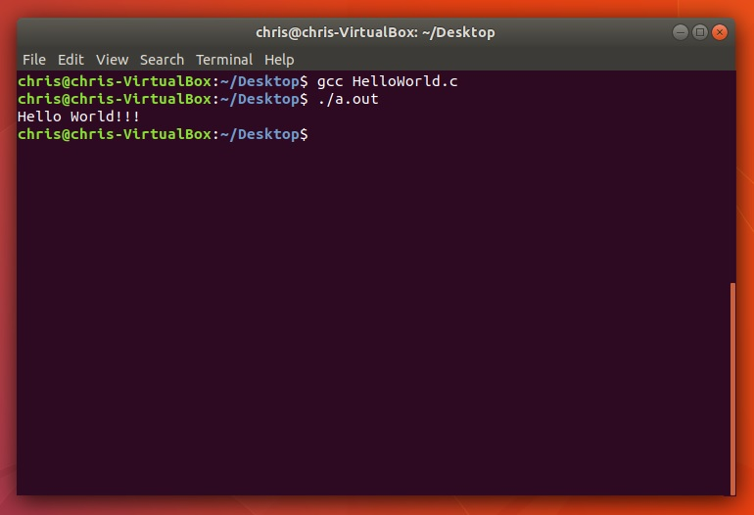

References

Petersen, R. (2000). *Linux, Programmer's Reference*. Berkeley, Calif: McGraw-Hill Professional.

The Linux man-pages Project. Retrieved from <https://www.kernel.org/doc/man-pages/> on 25 January 2018.